**LEACH PROTOCOL ENHANCEMENT FOR INCREASING WSN LIFETIME**

**Objective:**

The S-LEACH is the proposed protocol enhances and improves the network life time, data transmission and energy-efficiency .

**Hardware & Software Requirements:**

**Software:** Matlab R2018a.

**Hardware:**

**Operating Systems:**

• Windows 10

• Windows 7 Service Pack 1

• Windows Server 2019

• Windows Server 2016

**Processors:**

Minimum: Any Intel or AMD x86-64 processor

Recommended: Any Intel or AMD x86-64 processor with four logical cores and AVX2 instruction set support

**Disk:**

Minimum: 2.9 GB of HDD space for MATLAB only, 5-8 GB for a typical installation

Recommended: An SSD is recommended a full installation of all Math Works products may take up to 29 GB of disk space

**RAM:**

Minimum: 4 GB

Recommended: 8

**Project Flow:**

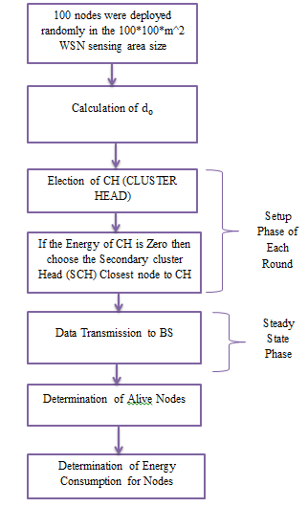

**Block diagram of proposed method**